Accelerating Markov Random Field Inference Using Molecular Optical Gibbs Sampling Units

Corresponding author

Siyang Wang ; Xiangyu Zhang ; Yuxuan Li ; Ramin Bashizade ; Song Yang ; Chris Dwyer ; Alvin R. Lebeck

Duke University

Keywords

Bayes methods, graphics processing units, inference mechanisms, iterative methods, learning (artificial intelligence), Markov processes, Monte Carlo methods, random processes, statistical distributions

新器件; 模拟器件; 物理模拟

Summary

*Challenge*

Many approaches in statistics and machine learning utilize probabilistic algorithms that **generate samples from parameterized probability distributions** (e.g., exponential distribution with a decay rate). Markov Random Field (MRF) Bayesian Inference can be used for a broad class of applications, including image processing (e.g., image segmentation, motion estimation, stereo vision, texture modeling), associative memory, etc. The overall goal of a specified MRF model is often to determine the most likely value for each random variable given the observed data, achieved in Markov Chain Monte Carlo (MCMC) sampling by iteratively sampling the random variables according to the conditional dependencies and then identifying the mode of the generated samples. However, **MCMC becomes inefficient** for many inference problems in practice, especially those with high dimensionality (many random variables) and complex structure. MCMC can **require many iterations to converge** to a solution and the inner loop incurs the overhead of sample generation from prescribed distributions.

*Contribution*

To be concluded, the authors proposed **a new hardware based on physical process** to generate specific random variable from a parameterized distributions in a high speed, which meets the need of certain probabilistic algorithms.

To solve the MCMC problem, the authors proposed a new hardware using physical device to supports a wide variety of probabilistic algorithms. This paper exploit the physical properties of molecular-scale optical devices. The authors build on recent work that provides a theoretical foundation for creating novel probabilistic functional units based on **Resonance Energy Transfer** (RET) that can approximate virtually arbitrary probabilistic behavior and generate samples from general distributions. Further, the authors introduce the concept of a RET-based Sampling Unit (RSU), a **hybrid CMOS/RET functional unit** that generates samples from parameterized distributions. An RSU specializes the calculation of distribution parameters in CMOS and uses RET to **generate samples from a parameterized distribution in only a few nanoseconds**. To accelerate MRF inference using MCMC, authors introduce RSU-G, **a Gibbs Sampling unit** based on the ‘first-to-fire’ exponential unit. Our specific RSU-G unit supports first-order MRFs with a smoothness-based prior, which includes many image processing applications (e.g., image segmentation, motion estimation, stereo vision).

Such RSU can be integrated into GPU, or used as a discrete accelerator.

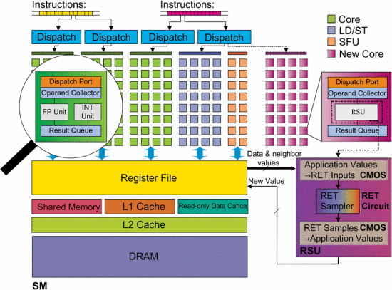

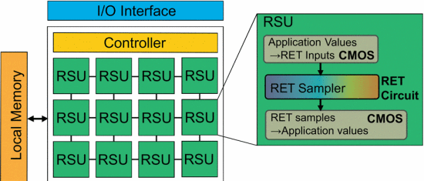

*Result*

The simulations shows that a GPU augmented with RSU-G units can achieve **speedups of up to 3 and 16** for image segmentation and motion estimation, respectively. A discrete accelerator with 336 RSU-G units achieves speedups of 21 and 54 assuming a 336GB/s memory BW limitation. The novel optical components of RSU-G units consume very little power (0.16 mW) and area (0.0016 mm2). Synthesizing the CMOS portions of RSU-G in 15nm reveals power of 3.75 mWand area of 0.0013 mm2 for a total RSU-G power of 3.91 mW and area of 0.0029 mm2.

*Comments*

The hardware is some sort of True Random Generator, which generate random number from physical process. The idea of using a physical process to accelerate time-costing step in certain algorithms is attractive, but such unit are therefore limited to this class of algorithms. The device is not significantly related to neural networks.